Project Design Phase-IITechnologyStack(Architecture&Stack)

|  |  |
| --- | --- |
| Date | 14October2022 |
| Team ID | PNT2022TMID54090 |
| Project Name | IoT Based Smart Crop Protection System for Agriculture |
| Maximum Marks | 4 Marks |

TEAMLEAD:

DHARUN.E

**TEAM MEMBERS:**

1.GOKULAKRISHNAN

2.MOHAN RAJ

3.KRISHNA TEJA

Technical Architecture:

The architectural diagram of the model is as below and the Technology used is shown intable1&table 2

**Reference:**https://smartinternz.com/guided-project/iot-based-smart-agriculture

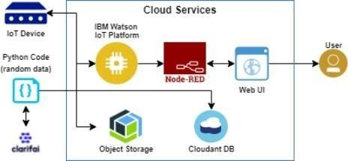

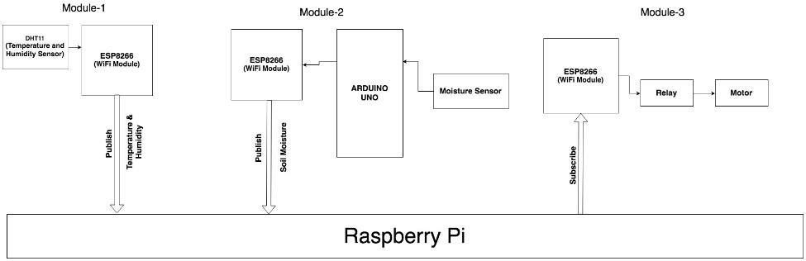

FIG. 1. BLOCKDIAGRAM

Table-1:Components&Technologies:

|  |  |  |  |
| --- | --- | --- | --- |
| **S.No** | **Component** | **Description** | **Technology** |
| 1. | UserInterface | How user interacts with application e.g., MobileApplication | HTML, CSS, JavaScript / Angular JS /NodeRed. |
| 2. | ApplicationLogic-1 | Logic foraprocessinthe application | Java /Python |
| 3. | ApplicationLogic-2 | Logic foraprocessinthe application | IBMWatsonSTTservice |
| 4. | ApplicationLogic-3 | Logic foraprocessinthe application | IBMWatsonAssistant |
| 5. | Database | DataType,Configurationsetc. | MySQL, NoSQL,etc. |
| 6. | CloudDatabase | DatabaseServiceonCloud | IBMDB2. |
| 7. | FileStorage | Filestoragerequirements | IBM Block Storage or Other StorageServiceorLocalFilesystem |
| 8. | ExternalAPI-1 | PurposeofExternalAPIusedintheapplication | IBMWeatherAPI,etc. |
| 9. | IoTModel | Purpose of IoT Model is for integrating the sensorswithauserinterface. | IBMIoTPlatform |
| 10. | Infrastructure(Server/Cloud) | Application Deployment on Local System / CloudLocalServerConfiguration:  CloudServerConfiguration: | Local,CloudFoundry,Kubernetes, etc. |

References:

<https://smartinternz.com/guided-project/iot-based-smart-agriculture><https://www.computerweekly.com/news/252504285/How-IoT-and-machine-learning-are-automating-agriculture><https://components.omron.com/us-en/solutions/iot>